
Nicholas Wyrwas

Travelr Getaways Application

CS 465 Project Software Design Document
Version 1.2

Table of Contents

CS 465 Project Software Design Document 1
Table of Contents 2
Document Revision History 2
Instructions 2
Executive Summary 3
Design Constraints 3
System Architecture View 3
Component Diagram 3
Sequence Diagram 4
Class Diagram 4
API Endpoints 4
The User Interface 4

Document Revision History

Version | Date | Author | Comments
1.0 | 05/22/25 | Nicholas Wyrwas | Completion of all sections in modules 1-3.
1.1 | 06/14/25 | Nicholas Wyrwas | Added sequence/class diagrams with detail. And added context for API endpoints.
1.2 | 6/25/25 | Nicholas Wyrwas | Completed All sections that were not covered in the document.

Instructions

Fill in all bracketed information on page one (the cover page), in the Document Revision History table, and below each header. Under each header, remove the bracketed prompt and write your own paragraph response covering the indicated information.

Executive Summary

My current work for the client Travlr Getaways involves creating a full-featured web application. This executive summary presents a critical evaluation of the project's objectives and structure along with its architectural design while detailing the constraints and solutions and explaining how the proposed approach meets the travel management and booking needs as defined by the client. For developing the Travlr Getaways web application with the right architecture I'm using the "MEAN" stack which consists of MongoDB, Express, Angular JS and Node. Js. These architecture sets used in web application development make it possible for me to create an application that is optimized and efficient while maintaining flexibility and strong security without compromising performance or security. The application features a customer-facing website section which allows users to easily access key functions such as making reservations and searching for rental options. The administrator's Single-Page Application (SPA) delivers status information about the system and data to enable fast tracking of potential problems and trends. Through this SPA system administrators can manage application backend functions which improves user experience for customers and maintains administrative efficiency.

Design Constraints

The Travlr Getaways web app requires optimization strategies for performance to manage large data volumes effectively. Technical scalability is essential to ensure the system or organization can efficiently handle high traffic loads during peak periods and when workloads expand which will affect loading speed and minimize HTTP requests while maintaining server responsiveness and optimizing image formats and sizes. It is essential to keep storage and sensitive data secure among other constraints.
Additional elements that need protection include user payment details along with project deadlines and financial budgets. Travlr Gateways application development faces design limitations which can significantly affect performance and scalability while compromising security when handling large data volumes together with heavy traffic loads and sensitive user information. To achieve optimal application performance developers must identify and resolve these limitations during the development process.

System Architecture View

Component Diagram
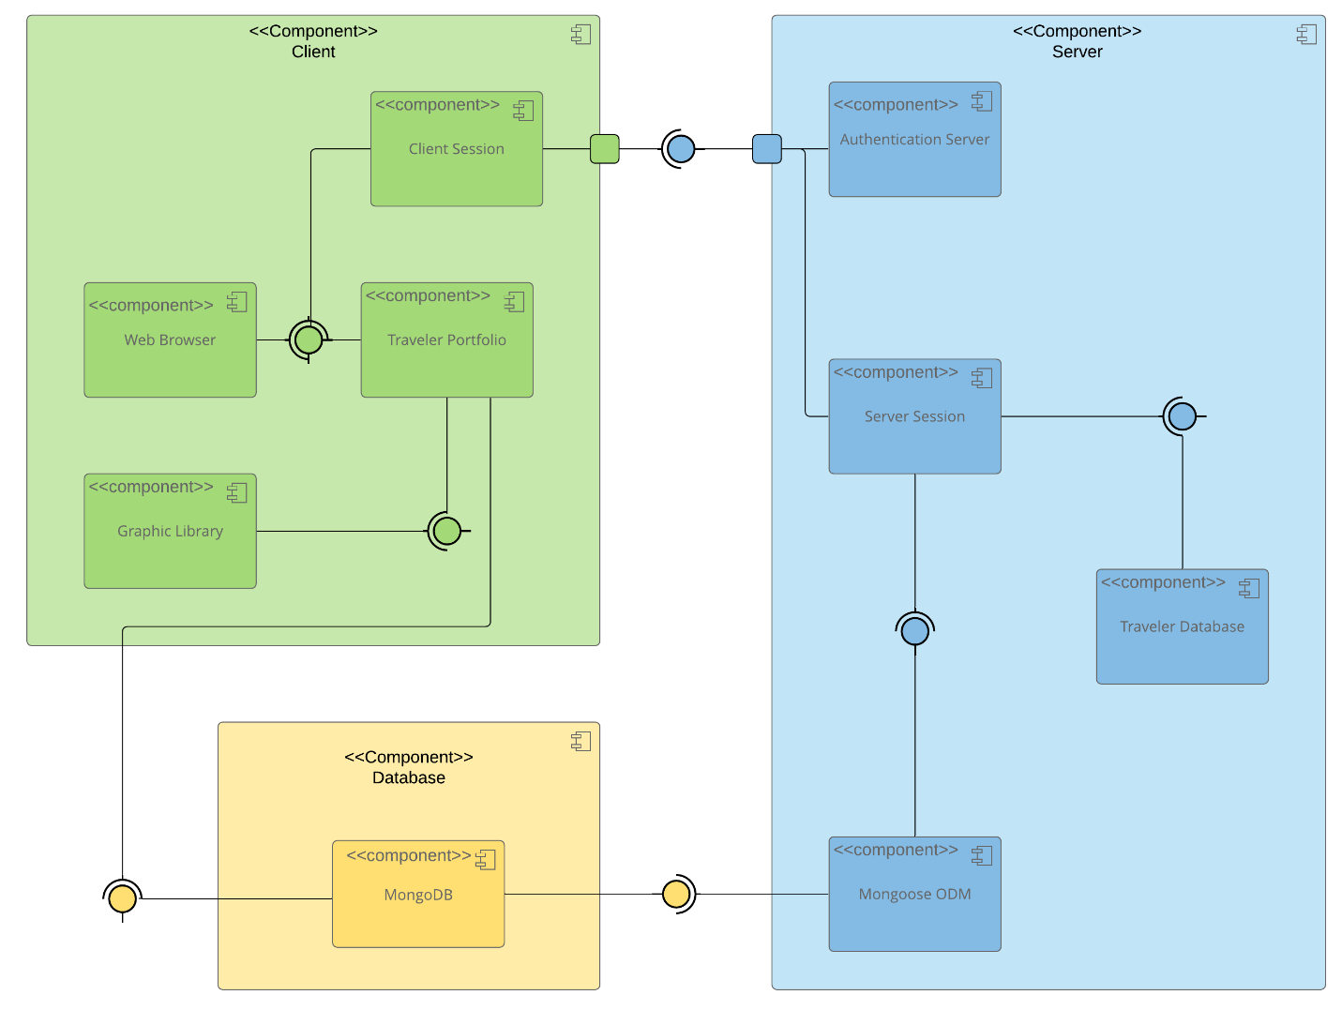

A text version of the component diagram is available: CS 465 Full Stack Component Diagram Text Version.

The overall system architecture of the Travlr Getaways web application shows a component diagram where the SDD is designed with three of the following tiers: The client-side user interface operates similarly to Angular while the system uses a Node.js powered back-end server to communicate with MongoDB for persistent storage of user data including vacation package searches and bookings. The application sends HTTP calls to perform data retrieval and updates. The system handles user authentication while managing session information and supervises all booking-related transactions. Express.js routes requests to the correct data handling functions while MongoDB provides an advanced database solution for efficient application data management including user profiles and other necessary data components. The system retains a comprehensive destination database which includes geographic locations along with descriptive texts and visual images. MongoDB provides expert management of travel packages by handling their pricing structures along with their itineraries and availability data and booking records. The document-oriented structure of the database provides exceptional storage and retrieval capabilities which make it ideal for our application. Application Programming Interfaces (APIs) will enable interactions with external services such as payment gateways. The system components work together seamlessly to provide users with the best possible experience.

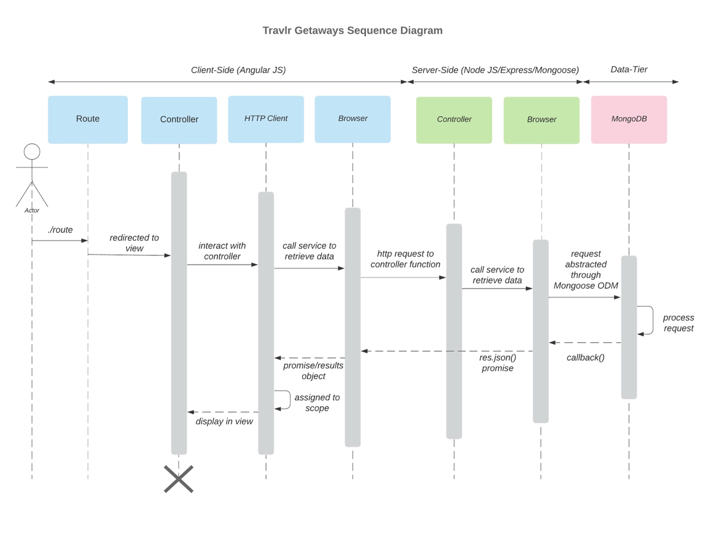
Sequence Diagram

The sequence diagram above illustrates how the client interacts with the server and database components in the web application architecture. The diagram specifies the ordered communication steps needed to authenticate a user before accessing system data. A user starts the authentication process by submitting a login request through the client-side interface. The controller manages the request initially by functioning as an intermediary between the HTTP client and the user's browser to properly format and dispatch the request. The browser sends the request to the server-side controller that processes logic and manages backend communication as an intermediary. The server-side controller retrieves necessary data from the database when it receives a request. After the database returns information to the server-side layer it is transmitted to the client-side browser for delivery. The controller receives data from the client browser to generate user interface elements which enable users to access requested information easily and interact seamlessly.

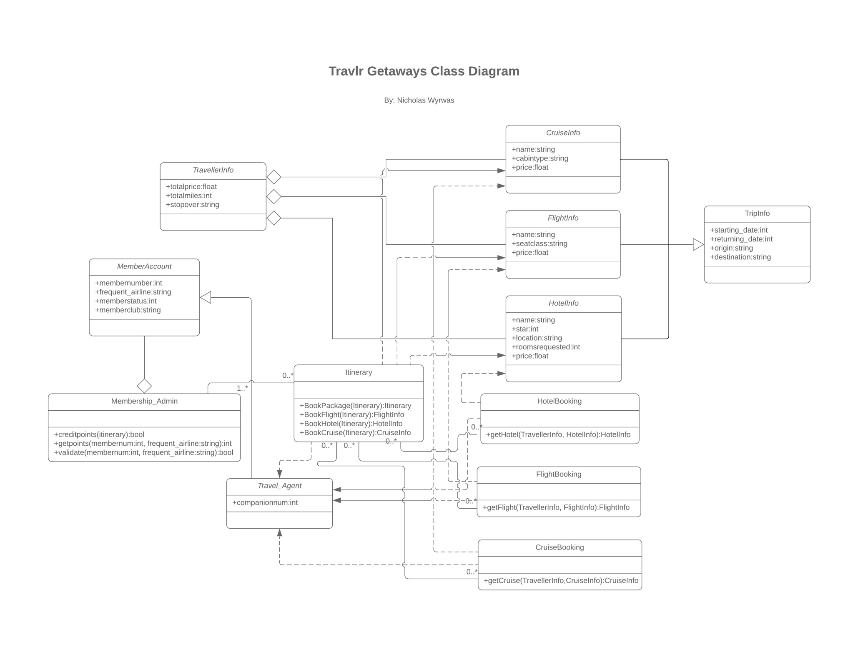
Class Diagram

<Illustrate the JavaScript classes of the web application by completing a class diagram for the web application. Insert an image of the class diagram here.>

The class diagram above displays how the core application functionality emerges from the structural connections between its various classes. The diagram shows the connections between system components and demonstrates how data organization occurs throughout the application. The TravellerInfo class functions as the storage unit for individual travel data and operates as a reference hub for travel elements like CruiseInfo, FlightInfo, and HotelInfo which provide specific travel option details. The Itinerary class captures booking information by linking together HotelBooking, FlightBooking, and CruiseBooking classes which represent the travel choices users plan or select. The TripInfo class establishes fundamental data definitions and metadata to describe the design and properties of CruiseInfo, FlightInfo, and HotelInfo which ensures uniformity and meaning across these travel classes within the system.

API Endpoints
Method | Purpose | URL | Notes
GET | <Retrieve list of things> | </api/things> | <Returns all active things>
GET | <Retrieve single thing> | </api/things/:thingId> | <Returns single thing instance, identified by the thing ID passed on the request URL>
POST | <This creates a list of things> | </api/things> | <Used to create a new list of things>
POST | <This will create a singular thing> | </api/things/:thingId> | <Used to create a singular thing within that instance, Which could be identified by the thingID from the request URL>
PUT | <This will update the list of things> | </api/things> | <This will update all of the current active things>
PUT | <This will update the singular thing> | </api/things/:thingId> | <This will update the singular thing, which is identified from the thingID from the request URL>
DELETE | <Deletes the list of things> | </api/things> | <This will delete all things>
DELETE | <Deletes the singular thing> | </api/things/:thingId> | <This will delete that singular thing, identified through the thingID from the request URL>

The User Interface

<Insert screenshots from the development of the SPA development to show the following: (1) a unique trip, added by you, (2) the Edit screen, and (3) the Update screen.>

The Angular project structure is based on a modular design where components, services, and routing are separated into distinct modules and folders. It supports scalability and maintainability by providing a clear hierarchy of files and dependencies, each serving a specific purpose. The front-end project structure is different from Express back-end because the Express directory arrangement is less nested, more linear and service-oriented. An SPA (Single-Page Application) allows dynamic updates of specific segments of a web page without requiring full page refreshes. This enhances user experience by providing faster and seamless interaction. The SPAs functionality includes real-time data binding, dynamic state changes, and reactive user interfaces. This is achieved by using Angular's two-way data binding, which synchronizes data between the application and the UI components. Also, it contrasts a simple web app, where static HTML pages are generated and served using traditional HTTP requests. They would lack the interactivity and efficiency of SPAs. The SPA was tested using create-trip, edit-trip, and update-trip forms. After the form creation and editing, the Trip data was retrieved using a GET request and updated using a PUT request. The correct functionality in the full stack application is confirmed by the success in the linkage of the Angular and Express/MongoDB portions of the application.

